1. Event Viewer
   * Use Management Console (or Control Panel) to Access Event Viewer
   * Insert snip of your Event Viewer Screen

|  |
| --- |
|  |

* + Select the first “event” , and click for more information
  + Insert snip of your Event Viewer Screen with the additional information

|  |
| --- |
|  |

* + Sort your list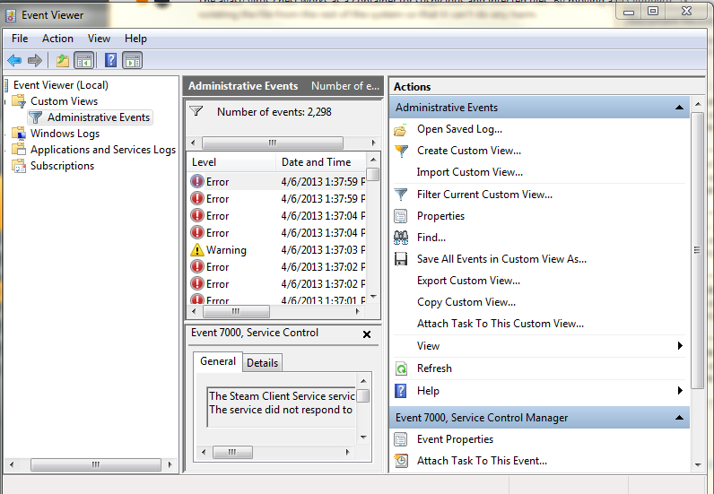 so Errors appear first (the Warnings and Information are less serious)